Underwriting Team

Central Trust Limited  June 2022

cASE SUBMISSION & Referral PROCESS

Contents

1 - Submitting a case via the Portal: 2

2 - Document Upload Guide: 2

3 - Quick Wins: 4

4 - E-mailing Information & Documents: 5

5 - Progress of your case: 5

6 - Re-quoting: 5

7 – Referral Process: 6

8 - Contact us: 7

**Change to our Submission Process:**

With effect from Monday 13th June all new applications can be submitted and supporting documentation uploaded via the portal.

The following pages explain the new process for you to follow.

# 1 - Submitting a case via the Portal:

The process for completing an AIP will not change, you will complete each screen, adding in the various customer information as you go. When you get to the end of the process and a product has been selected, you will be taken to the home screen and at the top of the screen you will see the following

**AIP Illustration Produced (e.g. CT000011567)**

Once you have received all the signed documentation back from the applicant, along with any other checklist items, you can then submit the case and upload the documents (Note - to submit a case we require you to have received the Mandatory items listed on the Case Submission Form):

From the home screen, you will need to click on the Red Actions Button (below)



This will give you a series of options: See below

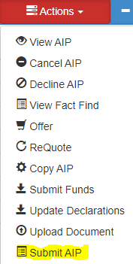

To submit the case to us, simply click “Submit AIP” as highlighted above in yellow.

This will place the case in our new underwriting system.

At this point, you will also have the opportunity to upload the supporting documents to us, the process for this is as follows.

# 2 - Document Upload Guide:

Once an AIP is submitted to us via the Portal the user will also have the ability to upload all supporting documents.

Whilst still in the CT case reference & within the portal, click on the “Actions Button” you will see in the dropdown menu, “Upload Document” as shown below.

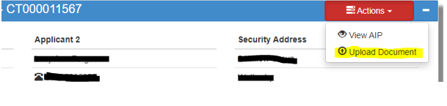

Click on the “Upload Document” Icon and the following will appear.

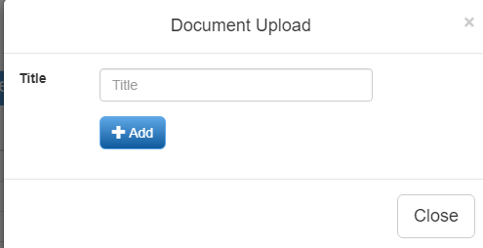

To upload a single document or a document with multiple pages or a full pack - (but all relative to the same case), simply insert a title, this would need to be relevant to the content of the document, a few examples would be:

Application pack

Mr’s Payslip Oct 2021

Copy of Lease

Home Insurance Policy

Mrs P60 2020

Valuation

Once the title has been entered, click on the + Add button, this should access your PC and relevant drives, including your desktop, find the appropriate document you wish to upload and double click on the document, this will then populate the document, its name and size of the document, as below.

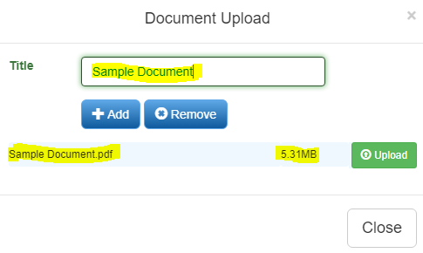

Once the document is visible as above, simply click on the Green upload Icon and the document will upload to our internal underwriting system and trigger a notification for us.

If you are uploading a document where multiple documents are contained within one, then within the “title” use the customer “surname” followed by “Part 1” – if there is more than one set of documents, then follow the same process using “Part 2” and so on and so forth.

**For Example –**

(Title) - Surname – Part 1 – Then Upload.

(Title) - Surname – Part 2 – Then Upload.

**Things to note:**

There is a maximum limit of 20MG per document uploaded.

You can upload most types of documents, these include – PDF’s (Preferred), Word documents, emails (Providing they are saved as text/a PDF only first) & Excel Documents.

You can only upload one file /document at a time.

You can view all the documentation that you have uploaded in the dropdowns in the portal when you are in the case itself, see example below. “Uploaded Documents”

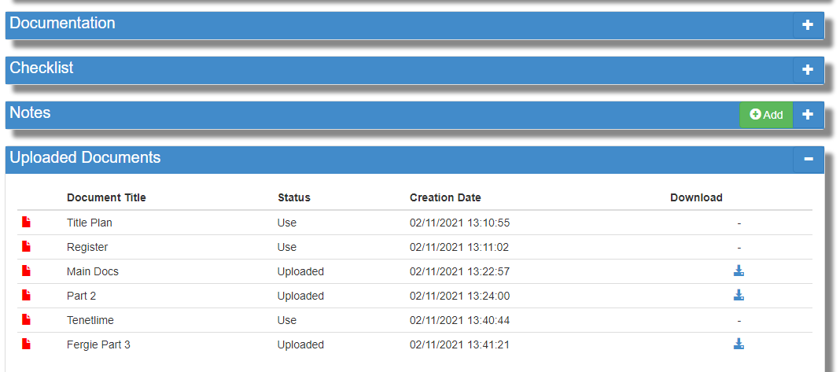

The Status will confirm its position, “uploaded” meaning as is and “Use” meaning the document has been reviewed and will be used.

# 3 - Quick Wins:

* Uploading CT’s standard document together as one pack – these are coded and will index (Categorise) automatically.
* If you have a large document like a 20 page lease – Upload as an individual document and title accordingly.
* Group document uploads relative to their type, for example, you may want to upload payslips, P60’s and any benefit entitlement letters together and index as “income” related documents and title accordingly.

# 4 - E-mailing Information & Documents:

Whilst uploading documents and information on a case via the Portal is the “Preferred” option, we can still receive e-mailed information & documents via e-mail.

E-mail to: [Chubinbox@centraltrust.co.uk](mailto:Chubinbox@centraltrust.co.uk)

**Note:** The AIP CT reference & customer surname **MUST** be contained in the “Subject Box” of the E-mail.

# 5 - Progress of your case:

You can monitor the progress of your case submission via the portal, simply access the portal and key in your case reference **(e.g. CT000011567)** and you will be able to see the “Status” of your case, as shown below in yellow.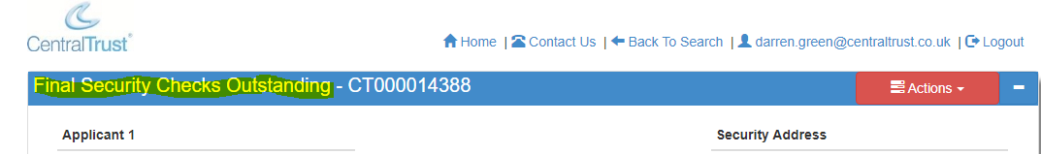

**Summary of Case Status:**

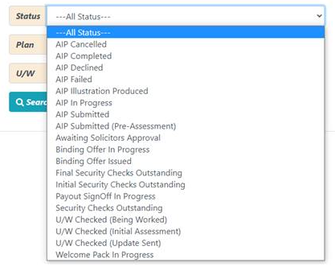

# 6 - Re-quoting:

Once the case has been submitted to us, we will take control of the case, if however, you need to re-quote, please contact us and we will arrange for the case to be passed back to you in the portal so can make any necessary changes and complete the requote, once this has been completed please submit the case again, as shown above and upload any additional documents, such as the New ESIS.

# 7 – Referral Process:

If you have a referral you can submit this to us via the portal, as follows.

Access the home screen and click on application search, select any application and from the ACTIONS button select view AIP, as below.

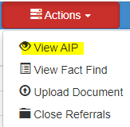

You will then see a menu down the left hand side of the screen and under “AIP Tools” you will see “Contact Mortgage Desk” as below

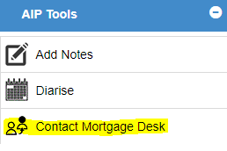

Click on “Contact Mortgage Desk” and a referral page will appear asking for a description of the referral you wish to submit, once completed, click on the Submit button and the referral will be sent straight to the mortgage desk team who will review and contact you to discuss further. See below.

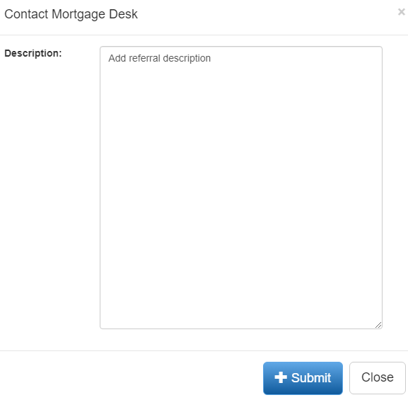

# 8 - Contact us:

If you have any questions on any of the above information or require assistance, you can contact your BDM or the:

**Mortgage Desk Team –**

[MortgageDesk@centraltrust.co.uk](mailto:MortgageDesk@centraltrust.co.uk)

01923 – 280599

0800 980 6100

**Underwriting Team –**

[Chubinbox@centraltrust.co.uk](mailto:Chubinbox@centraltrust.co.uk)

[underwriters@centraltrust.co.uk](mailto:underwriters@centraltrust.co.uk)

01923 – 280025

Thank you.